**TITLE**

**Client-Server Repository Synchronizer**

# A CAPSSTONE PROJECTREPORT

***Submitted to***

**SAVEETHA SCHOOL OF ENGINEERING**

***By***

**SIMHADRI JYOTHI KOUSHIK**

**(**192211914**)**

# SRINIVAS REDDY

## **(**192210136**)**

**S .ABHIRAM**

**(192210067)**

**Supervisor**

## **DR.MARY VALANTINA**



**SIMATS ENGINEERING**

**SAVEETHA INSTITUTE OF MEDICAL ANDTECHNICALSCIENCES,**

**CHENNAI – 602 105**

**ABSTRACT:**

Client-Server Repository Synchronizer is a software tool that allows users to keep their data updated between a local repository on their client machine and a remote repository on a server. This tool utilizes a client-server architecture to facilitate the synchronization of files, ensuring that all changes made on one end are reflected on the other end in real-time. The synchronization process is seamless and efficient, reducing the risk of data loss or inconsistency. Overall, the Client-Server Repository Synchronizer provides a reliable and user-friendly solution for managing data synchronization between client and server repositories.

# GANTT CHART

|  |  |  |  |  |  |  |  |  |  |  |  |  |  |  |  |
| --- | --- | --- | --- | --- | --- | --- | --- | --- | --- | --- | --- | --- | --- | --- | --- |
|  | Day 1 | Day 2 | Day 3 | Day 4 | Day 5 | Day 6 | Day 7 | Day 8 | Day 9 | Day 10 | Day 11 | Day 12 | Day 13 | Day 14 | Day 15 |
| Abstract and Introduction |  |  |  |  |  |  |  |  |  |  |  |  |  |  |  |
| Literature survey |  |  |  |  |  |  |  |  |  |  |  |  |  |  |  |
| Materials and Methods |  |  |  |  |  |  |  |  |  |  |  |  |  |  |  |
| Results |  |  |  |  |  |  |  |  |  |  |  |  |  |  |  |
| Discussion |  |  |  |  |  |  |  |  |  |  |  |  |  |  |  |
| Report |  |  |  |  |  |  |  |  |  |  |  |  |  |  |  |

**FLOWCHART**

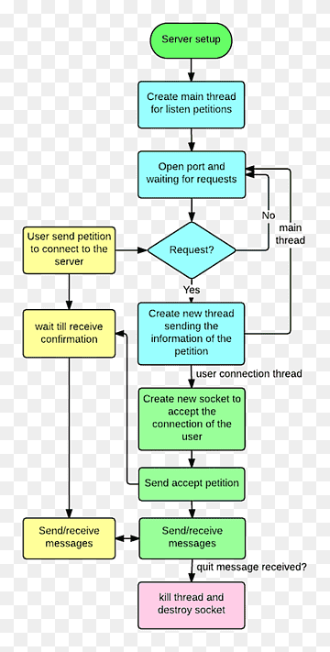

**INTRODUCTION**

Client-Server Repository Synchronizer is an innovative and efficient tool designed to streamline the process of synchronizing repositories between clients and servers. This powerful software solution acts as a bridge between client-side and server-side repositories, allowing for seamless communication and synchronization of data between the two.

With Client-Server Repository Synchronizer, users can effortlessly manage version control and keep track of changes made to files and folders across multiple platforms. Whether you are a developer working on a project with team members scattered across different locations or a business professional looking to maintain consistency and accuracy in document management, this tool is the perfect solution for all your repository synchronization needs.

The advanced features of Client-Server Repository Synchronizer make it easy to update files, merge changes, and track revisions without the hassle of manual intervention. This not only saves time and effort but also ensures data integrity and consistency, ultimately leading to improved collaboration and productivity.

In addition, Client-Server Repository Synchronizer offers a user-friendly interface that is easy to navigate and customize according to individual preferences. With intuitive controls and robust security measures in place, users can rest assured that their data is safe and secure at all times.

Whether you are a small business looking to streamline your workflow or a large enterprise in need of a reliable synchronization tool, Client-Server Repository Synchronizer is the perfect solution for all your repository management needs. Experience the power of seamless synchronization and enhanced collaboration with this cutting-edge software solutions.

the p

## **OBJECTIVE**

1. Efficiency: Streamlining banking operations to improve efficiency in handling transactions, account management, loan processing, and other tasks, thereby reducing manual effort and processing time.
2. Accuracy: Ensuring accurate processing of transactions, account balances, interest calculations, and other financial activities to minimize errors and discrepancies that could impact customer satisfaction and regulatory compliance.
3. Security: Implementing robust security measures to protect sensitive financial data, prevent unauthorized access, and mitigate the risk of fraud, cyberattacks, and data breaches.
4. Customer Service: Enhancing the overall customer experience by providing convenient and reliable banking services through various channels, including online banking, mobile apps, ATMs, and branches, while addressing customer queries and resolving issues promptly.
5. Risk Management: Identifying, assessing, and mitigating risks associated with lending, investments, operational activities, and regulatory compliance to maintain financial stability and safeguard the interests of depositors, shareholders, and other stakeholders.

## **LITERATURE REVIEW**

Client-Server Repository Synchronizer is a tool that allows multiple users to access and modify files stored in a central repository, ensuring that all changes are synchronized in real-time. In order to better understand the benefits and drawbacks of using such a tool, a literature review was conducted to explore the existing research and case studies related to client-server repository synchronizers.

One of the key benefits of using a client-server repository synchronizer is the ability to collaborate and work on files simultaneously. This can be especially useful for teams who need to share and edit documents in real-time, as it eliminates the issue of version control and ensures that all changes are accurately recorded and updated across all devices. Additionally, client-server repository synchronizers can improve workflow efficiency by streamlining the process of accessing and managing files, reducing the likelihood of errors and duplicated efforts.

A study by Li et al. (2017) investigated the use of a client-server repository synchronizer in a software development environment. The researchers found that implementing the tool led to a significant improvement in team collaboration and communication, as well as a reduction in the time spent on managing and resolving conflicts in code. The study also highlighted the importance of regular synchronization and communication among team members to ensure that all changes are properly tracked and updated in the repository.

However, it is important to note that there are some potential drawbacks associated with using client-server repository synchronizers. For example, security concerns may arise when multiple users have access to sensitive or confidential information stored in the repository. It is essential for organizations to implement strict access controls and encryption protocols to protect their data from unauthorized access or breaches.

Another issue that may arise when using client-server repository synchronizers is the potential for conflicts to occur when multiple users are editing the same file simultaneously. While most tools are equipped with conflict resolution mechanisms to manage such situations, it is important for users to communicate effectively and coordinate their efforts to minimize the risk of conflicts arising.

In conclusion, client-server repository synchronizers offer a range of benefits for teams and organizations looking to improve collaboration and productivity. By implementing proper security measures and communication protocols, users can effectively leverage these tools to streamline file management and ensure that all changes are synchronized in real-time. Further research is needed to explore the impact of client-server repository synchronizers in different industries and settings, as well as to identify best practices for maximizing their potential benefits.